Marinette County 4-H
Horse Project

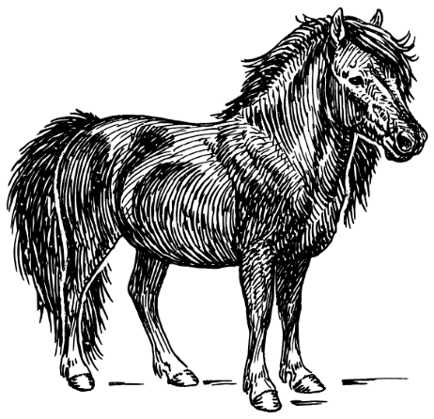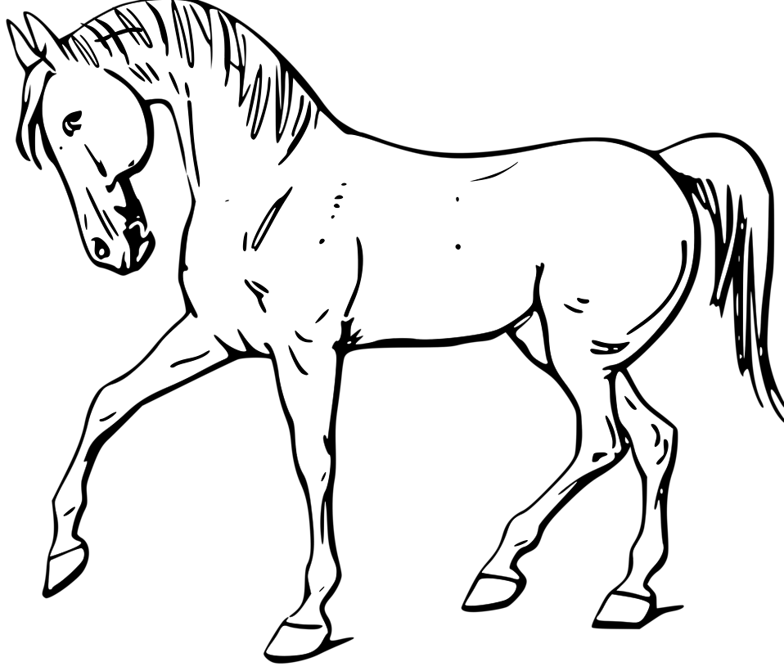

Handbook & Guidelines
2017-2018

Member Family__________________

The Marinette County 4-H Horse Project

PURPOSE
The purpose of this handbook is to provide you with information, inform you of important deadlines, rules and guidelines, and to answer commonly asked questions.

Once you and your parents have read this packet, you’ll need to complete and return the enclosed Acknowledgement Form to the Marinette County 4-H Horse Project Adult Advisors at the next meeting. If you need clarification of any of this information in this Handbook, it is your responsibility to speak with one of the Marinette County 4-H Horse Project Adult Advisors, Kevin Kotecki or Jeanie Goodwin.

EXPECTATIONS
All youth members and adults are expected to treat other members, leaders and their animals with proper respect and consideration. All members are responsible for knowing and following rules and regulations set forth here and in the Marinette County Fair Premium List. An adult will accompany youth members under the age of 12 to horse project activities. Please refer to the Marinette County Fair Premium List for equine health requirements needed to exhibit at the Fair.

BASIC INFORMATION
You don’t need to own a horse to participate. Areas of participation with and without a horse are described under the Opportunities section. Please contact a horse project Advisor for advice on a suitable partner for horseless horse participation. Enrollment in the Marinette County 4-H Horse or Horseless projects is open to anyone in grades 3 – 13. You must be a member of the Marinette County 4-H program, but may live in a surrounding county. Anyone in grades 3-13 may participate with (or without) a horse.

HOW DO I PARTICIPATE?

New enrollments: Anyone enrolling in 4-H for the first time must be enrolled with Marinette
County via the 4-H Online website (wi.4honline.com) by May 1st of the exhibit year in order to participate in the Fair.

Re-enrollments: Anyone re-enrolling in 4-H must be enrolled with Marinette County via the
4-H Online website (wi.4honline.com) by the November 30th deadline.

To exhibit at the Marinette County Fair: Marinette County Fair Premium List booklets will
be available on the Marinette County Fair website (marinettecountyfair.com). A limited number of printed booklets will be available from your club general leader or from the Marinette County UW Extension Office. Entries to the Marinette County Fair need to be turned in to the UW Extension office along with other required project forms by July 1.

Coggins Test: The State of Wisconsin requires a negative Coggins test be completed prior to any
organized horse event or gathering (trail rides, etc.). This test must be done by a licensed veterinarian to show that your horse does not carry the incurable disease Equine Infectious Anemia. Test results are valid for 12 months from the date that the blood sample was drawn. Any time your horse leaves home the original test paper must accompany you. All events, shows, clinics, drill team, trail rides and Fair will require a copy of this test paper result be left at the site of the event.

Health Certificate: For those members whose horses are stabled in Michigan, a health certificate completed by your veterinarian is required when your horse participates in activities in Wisconsin.

Premise ID: The State of Wisconsin requires a Premise ID Number for farms or hobby farms where livestock is kept. There is no charge to register. If your horse is stabled other than at your property, that land owner’s premise ID number is to be used. This number is required on entry forms for the Fair, County and State shows. To obtain a number go to the following website:
www.datcp.state.wi.us/premises/index.jsp or call WLIC at 1-888-808-1910.

VOLUNTEERS
As a project member family, we need your help. The organization cannot function without volunteers, and opportunities abound to contribute time and talent! Parents are encouraged to be present and help at activities and events. Project Leaders must be 4-H Certified Adult Leaders. There is an adult leader certification training program provided through Marinette County UW-Extension.

PROJECT EVENTS, MEETING, ACTIVITIES
See the Marinette County 4-H Horse Project Calendar of Events available on the Marinette County 4-H Website: Marinette.uwex.edu (click on 4-H youth development, then horse project)

FUNDRAISING ACTIVITIES
You will be asked to participate in fundraising activities that are decided on by the membership. Generally these will include sponsorships and horse shows. Each family is required to participate in one fundraising event. Member support for ALL fund raising activities is vital to obtain funds needed for providing quality horse activities during the year.

COMMUNICATION
News and announcements about the project will be available on the county website at
http://marinette.uwex.edu/4-h-youth-development/marinette-county-4-h-horse-project/ and will be updated periodically. News will also be printed in the county 4-H newsletter. In addition members may check the Marinette County 4H Horse Project page on Facebook. Finally, members may receive meeting and activity reminders via text by enrolling in Remind 101. To sign up: Text 81010 as the address on your phone. For the message, type in: @marinettec. Then you will add some additional information and the message will be sent to our Vice President and Remind 101 administrator, Kennedy Chmela. She will then OK your entry and you will be good to go.

SAFETY RULES
Adults and youth participating in high risk activities, including horses, must wear protective clothing, head and foot gear. This includes when representing Marinette County 4-H at parades, trail rides, riding, driving and other horse related events. SEI approved helmets must be worn while mounted or driving at any time.

Minimum requirements for these programs are:

. Protective head gear (SEI approved helmet which properly fits the participant).
. Hard sole boots with a cut out heel. No plastic rain boots allowed. No tennis shoes.
. Clothing appropriate for the activity which will protect the participants from the elements
surrounding the event.

If 4-H is listed as a sponsor or co-sponsor of an activity (including the Horse Project), the grade exhibit policies (youth must be in 3rd grade and above) and the helmet and safety rules apply to all participants. This includes adults as they need to be positive role models.

Stallions (intact males) are not permitted at any 4-H function, by youth or adult. The only exception is a foal at the mare’s side.

A saddle (mounted) and bridle (mounted/cart) are required when mounted or driving.

Complete safety guidelines may be accessed at the state site:
http://fyi.uwex.edu/wi4haganimalscience/horse/

SPORTSMANSHIP AWARD....Always exhibit good sportsmanship.
During and the week of the Fair, a sportsmanship box and ballot slips will be available for youth, parents and leaders to vote for the youth who has exhibited good sportsmanship at meetings and various scheduled events during the year. The youth with the most votes will receive a Sportsmanship award from the county. They may also receive an award from the Wisconsin 4-H Horse Association. The award may only be received one time per member. See State Website at
http://fyi.uwex.edu/wi4haganimalscience/horse/
WHO CAN I CONTACT FOR MORE INFORMATION?

Adult Advisors:
Kevin Kotecki at 715-938-4868
Jeanie Goodwin at 715-938-2342 or e-mail jeanhgoodwin@gmail.com

4-H Youth Development Educator
Lisa Devine –Barribeau
715-732-7514 or e-mail lbarribeau@marinettecounty.com

WHAT OPPORTUNITIES EXIST?
There are many areas of participation – remember, you don’t need to own a horse to participate! Following are brief descriptions of some of the opportunities available:

COUNTY LEVEL:

Practice Nights: These are held at the Fairgrounds and are open to all Marinette County 4-H Horse Project members, their guardians and certified adult leaders on selected dates to practice your riding skills and prepare for the Fair and state shows. Two adult leaders must be present at all times which includes unloading and loading of animals.

Horseless Horse: If you don’t own a horse, you can team up with someone who does. You’ll be able to participate in project activities and exhibit in special classes at the county Fair.

Drill Team: A team of riders perform a choreographed pattern, set to music. Drill team performances take place during the county Fair.

Horse Shows: Horse show activities include both pleasure shows and speed shows.

Horse Project Library: Books, CDs & videos are available for check out at each meeting.

STATE LEVEL:
See the state website for more information about the many competitions held in May of each year: http://fyi.uwex.edu/wi4haganimalscience/horse/
These include: Hippology, Horse Bowl, Interpretive Reading, Demonstration or Illustrated Talk, and Speech

EDUCATIONAL EVENTS – STATE EXPO
Many of the projects exhibited at Marinette County Fair may also be shown at the State Expo. These include: Model Horse, Poster/Photography, Creative Writing, Art, Clothes Horse, Veterinary Science, Woodworking, Horse Judging, and Team Problems.

For more detailed information, forms and event dates please visit the official Wisconsin 4-H
website: http://fyi.uwex.edu/wi4haganimalscience/horse/ click WI 4-H Horse Assn Handbook

ADDITIONAL OPPORTUNITIES
The Wisconsin 4-H Horse Association also hosts the following events:

Wisconsin State Hunter & Dressage Show – annual show held in June with dressage show and clinic, over fences show and clinic, mini-event with cross country clinic for intermediate and advanced riders. This show is held at the Sheboygan County Fairgrounds.

Wisconsin State 4-H Gymkhana – horse speed and game show held annually the second weekend after Labor Day at the State Fairgrounds in West Allis, WI. All entries are submitted as a county.

Wisconsin State 4-H Horse Expo – annual event held during the third weekend in September at the State Fairgrounds in West Allis, WI. This event features many horse-related events. All members exhibiting a horse will participate in barn awards. All entries are submitted as a county.

Wisconsin 4-H Area Animal Science Day – series of (four) one-day events held around the state each summer where youth in the beef, dairy, horse, sheep and swine programs increase their decision making skills and knowledge of animals through judging and grading experiences.

Scholarship Opportunities – Wisconsin 4-H Foundation – the Wisconsin 4-H Foundation and generous sponsors provide funding for these educational scholarships to outstanding Wisconsin 4-H youth.

Northeast District 4-H Horse Association– open to enrolled 4-H horse and pony project leaders and youth. Represent your state district, attend meetings.

Wisconsin 4-H Horse Association – all enrolled 4-H Horse project adult leaders in the State of Wisconsin are automatically members of the Association. Report state and district news to county horse project. Attend two annual meetings and work at horse association events.

Wisconsin 4-H Youth Horse Association – all youth enrolled in Wisconsin 4-H Horse and Pony Project and the Horseless Project are automatically members of the Youth Association and constitute the voting body.

REGIONAL/NATIONAL LEVEL:
The Wisconsin State 4-H Horse Association selects youth who are eligible to compete at
Regional/National competitions. Opportunities to advance are available for:
. Public Speaking
. Demonstration/Illustrated Talk (Team & Individual)
. Horse Judging
. Hippology
. Horse Bowl
MARINETTE COUNTY 4-H HORSE PROJECT CONSTITUTION

ARTICLE I – Name
Marinette County 4-H Horse Project

ARTICLE II – Purpose

- To promote and sponsor educational activities and events in horse science for youth.
- To provide members an opportunity to have their horse projects evaluated at the County Fair.
- To teach a greater understanding of the horse industry by holding clinics and teaching meetings that enhance the growth and development of youth.
- To distribute the responsibilities of the Horse Project among all families involved in the Horse Project.
- To establish rules and govern the compliance of regulations for participation in the Horse Project.
- To promote sportsmanlike conduct among all youth/adult members and families to ensure enjoyment and safety of equine activities throughout the year.

ARTICLE III – Membership

- A project member must be in third grade and may continue in 4-H through the next 4-H year following their graduation from high school. Kindergarten, first and second graders are enrolled as Cloverbuds and are not eligible to show live animals. However, educational (non-animal) opportunities may be made available for Cloverbuds.

- Membership is open to all 4-H members (within grade parameter) enrolled in Marinette County 4-H Horse or Horseless Horse project – regardless of that person’s race, color, creed, religion, sex, national origin, disability, ancestry, sexual orientation, pregnancy, marital or parental status.

- Membership shall consist of all youth 4-H members currently enrolled in the Horse or Horseless Horse Project. Enrolled youth members in the Horse or Horseless Horse Project shall constitute the voting body.

- The following requirements must be met to hold a charter and be recognized as a 4-H club/project in Wisconsin.

- Club Name
- Five or more youth from at least three families
- Adult leadership that has been approved through the Youth Protection Program
- Educational plan which meets the purposes of the 4-H program

- Youth involvement in leadership and decision-making
- Meet on a continuing basis
- Have written operating guidelines, bylaws or constitution approved by members to govern the club.
- Complete the 4-H Annual Charter Renewal Packet that includes critical communication, legal, financial and educational accountability requirements. All blanks must be completed. This is submitted to the county UW-Extension office by November 1 annually.

ARTICLE IV – Officers
The youth member officers of this project shall be a president, vice-president, secretary and treasurer.

ARTICLE V – Amendments
The constitution may be amended by a (simple) majority vote of the total membership at any regular meeting (provided notice of such amendments shall have been given at a previous meeting.)

ARTICLE VI – Project Leadership
The project shall be under the direction and guidance of local, certified 4-H Horse Project leader(s). Open to all adults regardless of that person’s race, color, creed, religion, sex, national origin, disability, ancestry, age, sexual orientation, pregnancy, marital or parental status. All adult chaperones, advisors and project leaders are required to participate in the WI 4-H Youth Protection Program.
*Adult Advisors
1. One adult advisor or two adult co-advisors shall be chosen by members to assist member officers with organizing meetings and other duties at the county level.
2. The adult advisors must be adult 4-H Horse Project Leaders who have met all 4-H leader requirements.

ARTICLE VII – Dissolution Clause
Upon dissolution of the Marinette County 4-H Horse Project, any assets must be turned over to a recognized 4-H club/unit/group, with the approval of the 4-H Leaders Association and the county 4-H Youth Development staff.

BY-LAWS
Revised January, 2017

ARTICLE I – Election of Youth Officers and Adult Advisors
- A candidate shall be nominated by any youth member of the Horse Project or adult leader from the floor.
- Elections shall be held at the October meeting. All youth members are eligible to vote. Ties for election of office are to be broken by voting again at the next scheduled meeting.
- Elected officers shall assume their duties at the November meeting. Officers will maintain their voting rights.
- Duties of the officers shall follow Robert’s Rules of Order.
- All terms shall be for one year.
- If an officer or advisor cannot fulfill their term, the decision will be made by majority vote to have a current officer or advisor step in for the remainder of the year or hold a vote for a new person to fill the position.

ARTICLE II – Duties of Youth Officers
- The president shall preside at all project meetings and perform other duties deemed necessary to the office. Create the agenda with the assistance of adult advisor.
- In the absence of the president the vice-president shall preside. Will coordinate communication.
- The secretary shall keep minutes of all meetings and submit copies to the UW-Extension office. Keep records of all proceedings of the project.
- The treasurer shall receive and take care of all money belonging to the project and shall pay bills and keep financial records.

ARTICLE III – Duties of Adult Advisors
Shall assist and support youth officers in planning meetings and educational opportunities and activities, completing the annual charter and helping project members, use best practices of Youth Development.

ARTICLE IV – Regular Meetings
The meetings will be held once a month. Additional meetings may be held as needed throughout the year.

ARTICLE V – Quorum
A quorum of the Horse Project shall consist of those youth members present.

ARTICLE VI – The Club Year
The Wisconsin 4-H membership year is defined as October 1 through September 30 for the purpose of definition in Wisconsin 4-H Policies. 4-H enrollment online is due by November 30. New members may enroll at any time, but must enroll by May 1 in order to exhibit at the county fair.

ARTICLE VII – The Club Fiscal Year
The Wisconsin 4-H fiscal year is defined as July 1 through June 30. The 4-H Horse Project financial books must be rectified annually by June 30. The Annual Financial Report is included in the 4-H Charter Renewal Packet. IRS 990 filing must be completed by November 15 by the county 4-H office.

ARTICLE VIII – Rules of Order
Robert’s Rules of Order shall govern the meetings of the project.

ARTICLE IX – Project Reporting
Annually, complete the 4-H Annual Charter Renewal Packet that includes critical communication, legal, financial and educational accountability requirements. This is submitted to the county UW Extension office by November 1.

ARTICLE X – Additional Project Policies
Wisconsin 4-H projects must adhere to all Wisconsin 4-H Policies, http://4h.uwex.edu/about-4-h/policies

ARTICLE XI – Amendments
Any youth member of the Horse Project may propose an amendment to the Constitution at a general meeting. It will be voted on at the following meeting, after posting and notification to all members in the Horse Project at least 14 days prior to the actual vote. Changes will be made by a majority vote of those members eligible to vote who are present at the Horse Project meeting.

ARTICLE XII – Committees
Committees of the Horse Project shall be structured as youth-adult partnerships and are open to adult volunteer leaders and members within the Horse Project. If no one volunteers, a rotation may be initiated. The following committees may be formed when needed:
Awards Project Pleasure Gymkhana Activities Open Show Business Miscellaneous
The responsibilities of the committees when formed are as follows:
- Appoint a Chairperson
- Meet any time the committee deems necessary
- Provide a means for feedback from members on relevancy of materials, events, etc.

ARTICLE XIII – Liability
Neither the officers’ board nor the Horse Project membership shall become legally liable for decisions rendered, put into effect, or published; nor for any action taken pertaining to the same.

ARTICLE XIV – Requirements for Fair
1. To show at the Marinette County Fair, youth members must attend at least four monthly Horse Project meetings held during the year of the fair prior to the opening day of the Marinette County Fair.
2. Members in grade 13 or enrolled following their high school graduation are exempt from attending four meetings as long as they have been a Marinette County 4-H member for at least two years prior. Must meet other fair requirements.

3. Each youth member must fill out a participation form stating that his or her Fair project animal(s) has attended one group activity off property prior to the Marinette County Fair.

4. By July 1, youth members must provide a list of horse/pony names to be shown at the Fair. In the rare exception where the animal from the list cannot be shown, the member must submit to the Horse Project Advisor a letter signed by a parent/guardian and veterinarian stating why another animal is to be used. It will then be at the Horse Project Advisor’s discretion to allow the change, providing all criteria have been met by the youth member.

5. Member must obtain at least one sponsorship. Members will work to obtain sponsorships as a group.

Revised February, 2017

Additional Information about Fair Requirements

Attendance Sheets are used at each meeting/event. It is YOUR responsibility to ensure that your name is on that attendance sheet.

You should attend a meeting/event for one (1) hour to receive attendance credit.

Parents do not count as attending for their child.

As always, if you have any questions please contact the Horse Project Adult Advisors,

Kevin Kotecki at 715-938-4868 or Jeanie Goodwin at 715-938-2342

Your Horse Project Year
CHECKLIST

I have:

_____ Enrolled in a 4-H club and the Horse Project by May 1, 2018.

_____ Had our horse(s) tested for Equine Infectious Anemia (Coggins test).
(Horse’s name on Coggins form must match name on fair entry)

_____ Had our horse(s) vaccinated with 4 in 1 or 5 in 1 vaccine.

_____An appropriate Premises ID number. Premises ID number to be written on the Coggins form.

_____ Signed up for the Fair using the Marinette County Fair Premium List.

_____ Met the Horse Project Fair eligibility requirements.

- Attended four (4) Horse Project meetings
- Obtained at least one sponsorship for the Fair
- My horse /pony has been in at least one “off the premises” activity

_____ Turned in all forms to the Marinette County UW Extension office by July 1 deadline:

- Copy of Coggins (original must be shown when you arrive at the Fair)
- Proof of vaccinations
- Premises ID (written on Coggins)
- Project Animal(s) Sign-Up Sheet
- Certificate of Off the Premises Activity Participation
- Fair Entry Horse Show Sign-Up Sheet
- At least one Sponsorship Form(s)

Important Phone Numbers

Adult Advisors:
Kevin Kotecki at 715-938-4868
Jeanie Goodwin at 715-938-2342 or e-mail jeanhgoodwin@gmail.com

4-H Youth Development Educator
Lisa Devine –Barribeau
Marinette County UW Extension
1926 Hall Avenue, Marinette WI 54143
715-732-7514 or e-mail lbarribeau@marinettecounty.com

4-H Youth Development Head Secretary
Nancy Servais
Marinette County UW Extension
1926 Hall Avenue, Marinette WI 54143
715-732-7514 or e-mail: nancy.servais@ces.uwex.edu

Marinette County Fair Horse Barn Superintendent
Julia Lepinski 920-897-3439

Notes:

ACKNOWLEDGEMENT
(Detach and return by January meeting*)

All 4-H horse project members in your family, along with your parents, must sign this form.

By signing and returning this form, you agree to accept the following requirements:

- We have received the Marinette County 4-H Horse Project Handbook & Guidelines, Rules and Eligibility Requirements.

- We have read and understand the contents of the Marinette County 4-H Horse Project Handbook & Guidelines.

- We agree to abide by the rules as stated therein.

- We understand that the requirements set forth in the Marinette County 4-H Horse Project Handbook & Guidelines must be fully met to be a member in good standing and to exhibit at the Marinette County Fair, Wisconsin State 4-H Gymkhana, Wisconsin State 4-H Horse Expo or Wisconsin State 4-H Hunter & Dressage Show.

Date:__________________

_____________________________ ________________________________

Member-print name Member-signature

_____________________________ ________________________________

Member-print name Member-signature

_____________________________ ________________________________

Member-print name Member-signature

_____________________________ ________________________________

Parent /Guardian-print Parent / Guardian-signature

Submit this form by the January meeting to the Project Adult Advisors.
* For new members enrolling in 2018, bring this to your next meeting.

